Chapter 4 The Enhanced E-R Model and Business Rules

Chapter Overview

The purpose of this chapter is to present some important extensions to the E-R model (described in Chapter 3) that are useful in capturing additional business meaning. In particular, we describe two types of extensions to the E-R model. First, the enhanced entity-relationship (EER) model includes constructs for supertype/subtype relationships. Second, the inclusion of new notation for business rules allows the designer to capture a broader range of constraints on the data model than were previously available.

Chapter Objectives

Specific student objectives are included in the beginning of the chapter. From an instructor’s point of view, the objectives of this chapter are to:

1. Introduce the concept of supertype/subtype relationships, and prepare the student to recognize when to use these relationships in data modeling.
2. Describe the use of specialization (top-down perspective) and generalization (bottom-up perspective) as complementary techniques for defining supertype/subtype relationships.
3. Introduce notation for specifying both completeness constraints and disjointness constraints when modeling supertype/subtype relationships.
4. Help students gain sufficient perspective so that they recognize when to use (and when not to use) supertype/subtype relationships in realistic business situations.
5. Describe the basic premises of a business rules paradigm.
6. Describe a simple framework for categorizing business rules.
7. Introduce notation for modeling typical operational constraints that can be incorporated in your EER diagram.
8. Discuss the universal data model.

Key Terms

Action | Derived Fact | Specialization
Action assertion | Disjoint rule | Structural assertion
Anchor object | Disjointness constraint | Subtype
Attribute inheritance | Enhanced entity-relationship (EER) model | Subtype discriminator
Completeness constraint | Enhanced entity-relationship (EER) model | Supertype
Corresponding object | Entity cluster | Supertype/subtype hierarchy
Derivation | Generalization | Total specialization rule
 | Overlap rule  Partial Specialization rule | Universal data model

Classroom Ideas

1. Introduce the concept of supertypes and subtypes with a familiar example, such as VEHICLE (subtypes are CAR, TRUCK, SUV, etc.).
2. Introduce the basic notation for supertype/subtype relationships (Figure 4-1). Use this notation to represent the example you introduced in (1). Introduce your students to all three types of notation.
3. Discuss the EMPLOYEE example with subtypes (Figure 4-2). Use this figure to introduce the example of attribute inheritance.
4. Use Figure 4-3 to discuss the two major reasons for introducing supertype/subtype relationships: unique attributes among subtypes, and unique subtype relationships.
5. Contrast generalization and specialization using Figures 4-4 and 4-5. Have your students suggest other examples that use each of these techniques.
6. Introduce the completeness constraint using Figure 4-6. Give other examples where either the total specialization rule or the partial specialization rule is more appropriate.
7. Discuss the disjointness constraint and related notation using Figure 4-7. For reinforcement, have the students work Problem 7 (Problems and Exercises) in class.
8. Introduce notation for a subtype discriminator (Figures 4-8 and 4-9). Discuss why a different notation is required for the two cases shown in these figures.
9. Discuss entity clustering and illustrate with Figures 4-13 and 4-14.
- Review the extended example of a supertype/subtype hierarchy shown in Figure 4-10. For reinforcement, ask the students to work problem 2 (Problems and Exercises) in class.
- Review universal data models and discuss how these are being used more widely today. Consider inviting an industry guest speaker to discuss how these universal data models are utilized in his/her company. If your students have access to computers during your class session, break the students into small groups and have them complete Problem & Exercise 16 then report back to the large class with their findings.
- Discuss the classification of business rules shown in Figure 4-18. Give examples for each type of rule.
- Discuss the notion of structural assertions, and illustrate with examples shown in Figure 4-19.
- Introduce the notion of action assertions, and illustrate with the examples shown in Figure 4-20. For this example, show how the business rule is captured with notation on the diagram.
- Ask your students for examples of other business rules they have encountered recently in their work, school, or home experience. See if they can diagram these rules using the notation provided in this chapter.

Answers to Review Questions

1. Define each of the following terms:
- Supertype. A generic entity type that has a relationship with one or more subtypes.
- Subtype. A subgrouping of the entities in an entity type that is meaningful to the organization.
- Specialization. The process of defining one or more subtypes of the supertype, and forming supertype/subtype relationships.
- Entity cluster. A set of one or more entity types and associated relationships grouped into a single abstract entity type.
- Structural assertion. A statement that expresses some aspect of the static structure of the organization.
- Anchor object. A business rule (a fact) on which actions are limited.
- Subtype discriminator. An attribute of the supertype whose values determine the target supertype or subtypes.
- Total specialization rule. Specifies that each entity instance of the supertype must be a member of some subtype in the relationship.
- Generalization. The process of defining a generalized entity type from a set of more specialized entity types.
- Disjoint rule. Specifies that if an entity instance (of the supertype) is a member of one subtype, it cannot simultaneously be a member of two (or more) subtypes.
- Overlap rule. Specifies that an entity instance can simultaneously be a member of two (or more) subtypes.
- Action assertion. A statement of a constraint or control on the actions of the organization.
- Universal data model: A generic or template data model that can be reused as a starting point for a data modeling project.

2. Match the following terms and definitions:
h supertype
k entity cluster
i structural assertion
a subtype
j specialization
d anchor object
f action
l subtype discriminator
c attribute inheritance
b overlap rule
e corresponding object
g derived fact

3. Contrast the following terms:
- Supertype; subtype. A supertype is a generalized entity type that has one or more subtypes, while a subtype is a subgrouping of the entities in a supertype.
- Generalization; specialization. Generalization is the process of defining a generalized entity type from a set of more specialized entity types, while specialization is the process of defining one or more subtypes of the supertype.
- Anchor object; corresponding object. An anchor object is a business rule on which actions are limited, whereas a corresponding object influences the ability to perform an action on another business rule.
- Disjoint rule; overlap rule. With the disjoint rule an instance of a supertype must be a member of only one subtype at a given time. With the overlap rule an instance of a supertype may simultaneously be a member of two or more subtypes.
- Structural assertion; action assertion. A structural assertion expresses the static structure of an organization whereas an action assertion is a statement of control on the actions of an organization.

- Total specialization rule; partial specialization rule. With the total specialization rule, each instance of the supertype must be a member of some subtype in the relationship. With the partial specialization rule, an instance of the supertype is allowed not to belong to any subtype.
- PARTY;PARTY ROLE: In a universal data model, PARTY represents persons and organizations independent of the roles they play whereas PARTY ROLE contains information about a party for an associated role.

4. Two conditions that indicate a designer should consider using supertype/subtype relationships:
- There are attributes that apply to some (but not all) of the instances of an entity type.
- There are relationships that apply to some (but not all) of the instances of an entity type.

- The reasons for entity clustering are:
  - Complex enterprise-wide E-R diagram.
  - Ability to have a hierarchical decomposition of data model.
  - Desire to focus part of the model on an area of interest to some community of users.
  - Ability to create several different entity clusters each with a different focus.

6. An example of a supertype/subtype relationship:
The supertype PERSON has many possible subtypes: MALE, FEMALE, INFANT, TEENAGER, etc, assuming these different types of persons have somewhat different attributes or participate in different relationships. In an organizational context, PERSON may have subtypes of EMPLOYEE, CONTRACTOR, CUSTOMER, VENDOR, MANAGER, etc.

7. Give an example of a(n):
- Structural assertion: a person is a customer of a store.
- Action assertion: a customer must have a credit limit greater than zero in
order to charge a purchase.

8. Action assertions can be classified in three ways. Each of the three ways has several types associated with it:
a. Based on the type of result from the assertion:
i. Condition: states that if something is true, than another business rule will apply.
ii. Integrity constraint: states something that must always be true.
iii. Authorization: states a privilege.
- Based on the form of the assertion:
- Enabler: if true, leads to the existence of the corresponding object.
- Timer: enables or creates an action.
- Executive: causes the execution of one or more actions.
- Based on the rigor of the assertion:
- Controlling: states that something must or must not happen.
- Influencing: items of interest for which a notification must occur.

9. An example of an enabler action assertion: an order can be entered into the system once
the customer’s credit has been verified.

10. An example of an executive assertion: assign a contract number to a vendor the first
time that the vendor supplies raw materials to Pine Valley Furniture.

11. Attribute inheritance is the property that subtype entities inherit values of all attributes of their supertype(s). This property is important because it makes it unnecessary to include supertype attributes redundantly with subtypes.

12. Give examples of:
- Supertype/subtype relationship where the disjoint rule applies: PERSON has subtypes MALE and FEMALE.
- Supertype/subtype relationship where the overlap rule applies: PERSON has subtypes INSTRUCTOR and STUDENT.

13. The types of business rules that are normally captured in an EER diagram include terms, relationship constraints, and supertype/subtype relationships (see Figure 4-11).

- The purpose of a subtype discriminator is to determine the target subtype (or subtypes) for each instance of a supertype.

- A packaged data model is most useful when one can easily customize it to the specific business (that is, the organization is very similar to other organizations for the same industry or purpose or the functional area is roughly the same as that functional area in other organizations). As long as the packaged data model is for the type of business or functional area, then it can generally be customized. The amount of customization depends upon the types of specialized business rules in place for the organization.

- [Note to instructor: After registering (free) at Bill Inmon’s site with an e-mail and password, you need to select the Data Models link. Several models are available for review.]

Two packaged data models appear as possible candidates for adaptation to the PVFC situation. The PVFC appears to combine elements from both the SALES and MANUFACTURING packaged data models. The SALES data model would need to be modified to include PVFC sales territories and salespersons. The SALES data model might also have to be adjusted to reflect Vendor provision of Raw Materials that PVFC assembles into Products that are sold. The SALES data model would also need to track PVFC employees and skills.

The MANUFACTURING data model appears to capture the PVFC data related to transforming Raw Material into Products, but seems to lack the tracking of the Order and Sales data. Overall, the SALES packaged data model seems to be the most promising for adaptation to PVFC’s situation.

- A subtype/supertype hierarchy is useful when you have several subtypes that are also supertypes. An example would be for bank accounts. At the first level, you can have savings, checking and loans. Underneath loans, there are several subtypes, including personal, auto, home, etc.

- A member of a supertype is always a member of at least one subtype when the rule of total specialization applies to an EERD.

  - An order contains many products and a product can be part of many orders. This fact is shown as the order_line associative entity in Figure 4-12.
  - An employee can be either management or union, but not both. This is shown by a subtype/supertype relationship in Figure 4-12.
  - A union employee can work in many work centers and a work center can have many union employees. This is shown by the Works_in relationship in Figure 4-12.
  - A regular customer does business in a sales territory, while a national customer does not do business in a particular sales territory. This is shown in the subtype/supertype relationship for Customer in Figure 4-12.
  - An employee can have many skills. This is shown as a multivalued attribute in Figure 4-12.

- A few derived facts for Pine Valley Furniture:
  - An order is supplied by one or more suppliers. This can be derived from the order_line, uses and supplies relationships in Figure 4-12.
  - The order total is calculated by adding the product of the quantity times the price for each order_line for a given order.
  - An order is produced in one or more work centers. This can be derived from the produced_in relationship and order_line associative entity in Figure 4-12.
  - An order is worked on by one or more employees. This can be derived from the produced_in relationship, the order_line associative entity and the works in relationship in Figure 4-12.
  - An order includes one or more product lines. This can be derived from the order_line associative entity and the includes relationship in Figure 4-12.

Solutions to Problems and Exercises

- An example listing follows for a GRADUATE STUDENT:

Attribute Name | Data Value
SSN | 736-94-1802
Name | Jessica James
Address | 25 Lake Dr. Medford OR 95106
Gender | female
Date_of_Birth | Oct. 23, 1967
Major_Dept | Computer Science
Test_Score | 986

2. 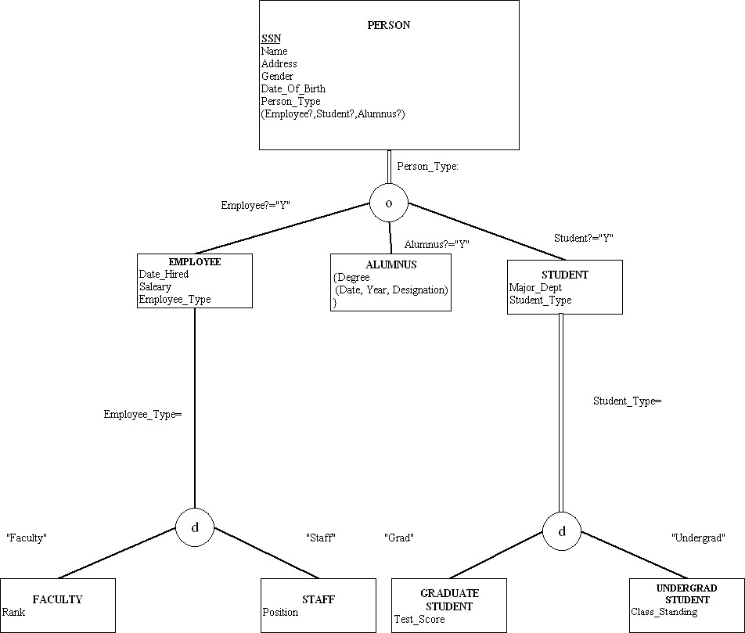

3. Please note that the problem does not explicitly state that Skill is a multivalued attribute. Given the fact that examples in the text have skill as a multivalued attribute, we have made this assumption here also.

EER Notation:
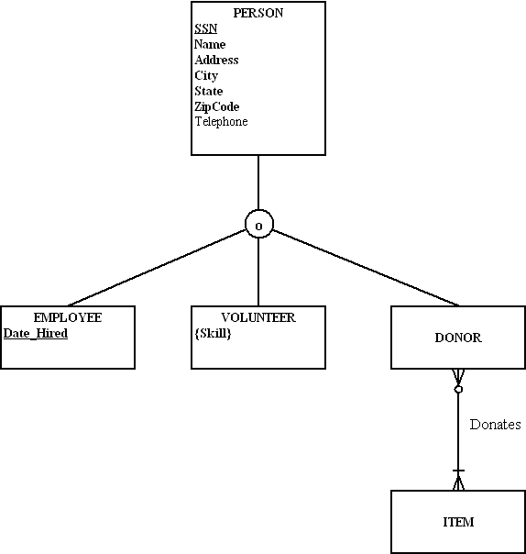

3) Visio Notation:
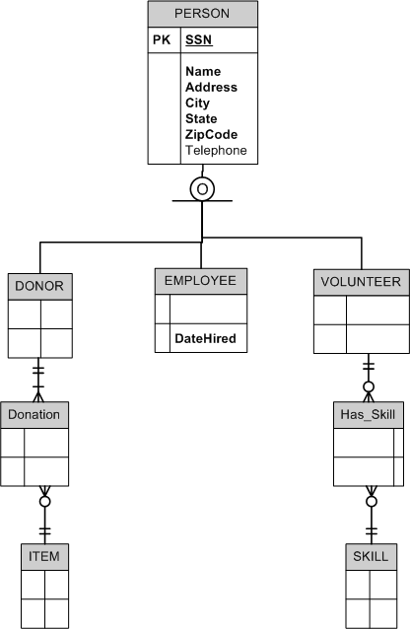
3) Subtypes inside Supertypes Notation
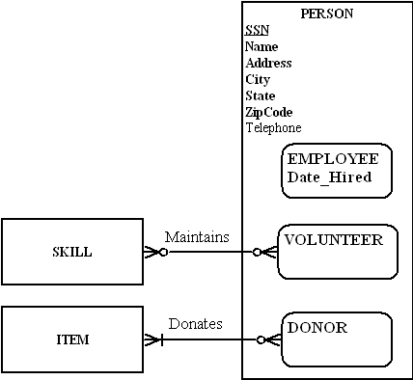

4. Note: Again, we have assumed that Skill is a multivalued attribute.

Standard EER Notation:
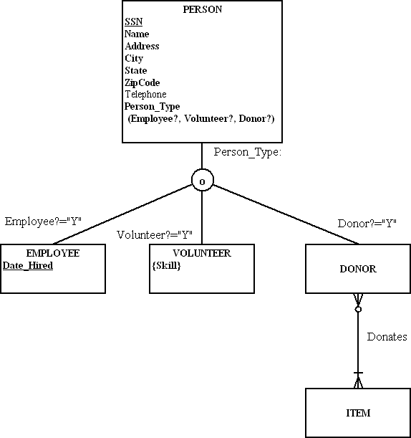
4) Visio Notation:
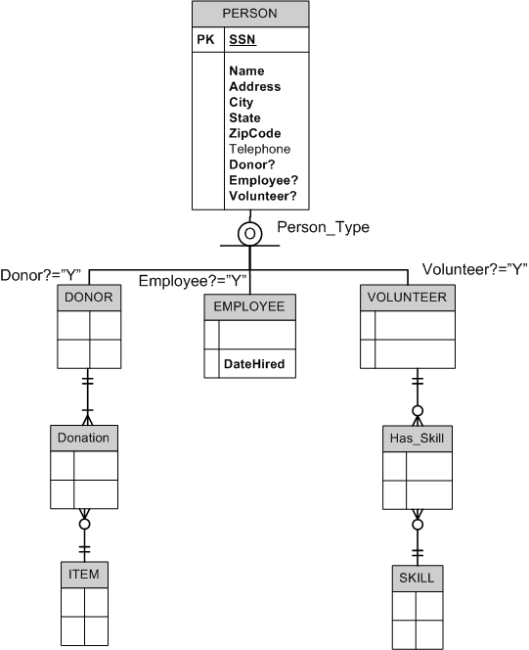
4) Subtypes inside Supertypes Notation:
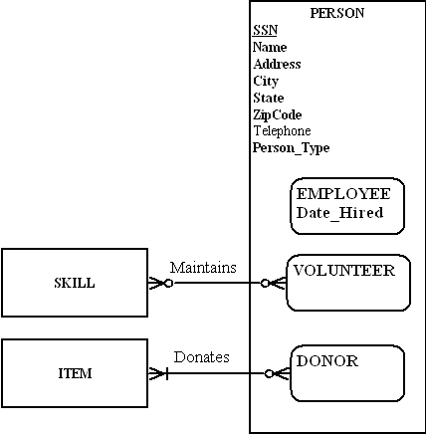

5. No, none of the vehicle classifications has a unique attribute or a unique relationship. Instead, Vehicle category likely should be an attribute of the Vehicle entity type.

6a.

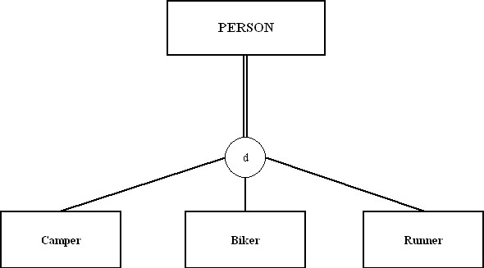

6b.
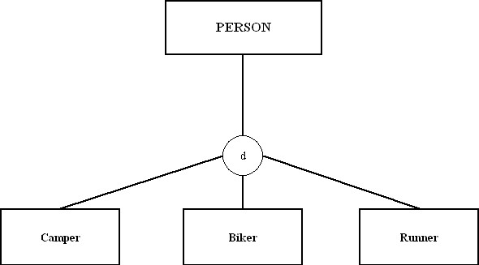

6c.

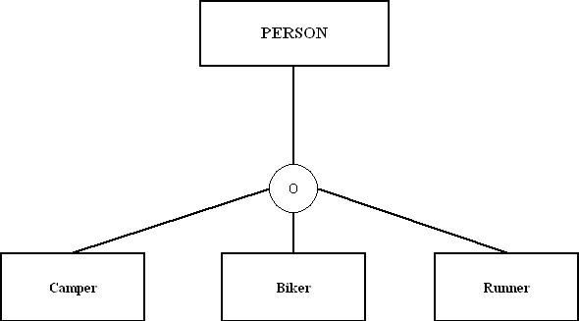

6d.
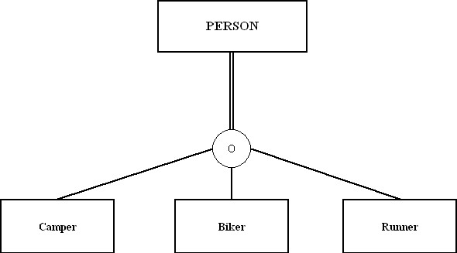

7. Standard EER Notation:

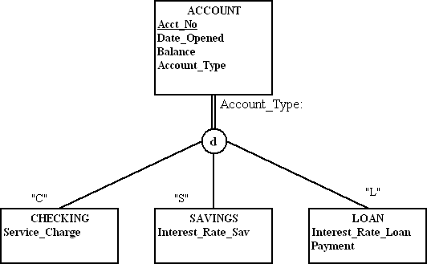

7) Visio Notation:

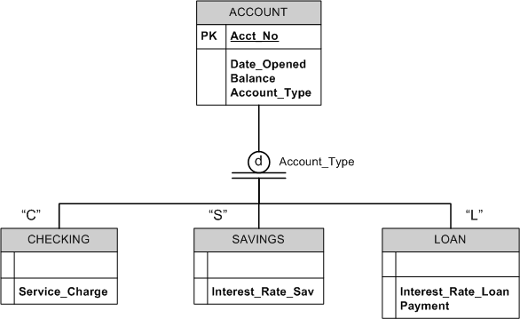

7) Subtype in Supertype Notation:

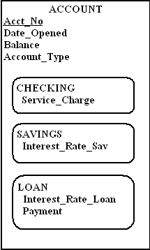
8. a. Sample definitions:
EMPLOYEE: a person who has signed an employment agreement or contract with the company,
HOURLY EMPLOYEE: an employee whose pay is based on number of hours worked.
SALARIED EMPLOYEE: an employee who receives a fixed salary each pay period.
CONSULTANT: an employee who has signed an employment contract and whose pay is based on an agreed billing rate.
Employee_Number: an employee’s social security number.
Employee_Name: an employee’s name consisting of first name, middle initial, and last name.
Address: an employee’s home address, consisting of street address, city, state, and zip code.
Date_Hired: the date when an employee signed an employment agreement or contract.
Hourly_Rate: the pay rate ($/hour) for an hourly employee.
Annual_Salary: the base annual salary for a salaried employee.
Stock_Option: the annual compensation (shares/year) of company stock for a salaried employee.
Contract_Number: the number on the employment contract signed by a consultant.
Billing_Rate: the compensation ($/hour or other stated period) on the employment contract signed by a consultant.

b. Sample integrity-constraint action assertions:

Employee_Number:
Each employee must have a unique employee number.
Employee_Name:
Each employee must have a name.
Address:
Each employee must have an address.
Date_Hired:
Each employee must have a date of hire earlier than or equal to today’s
date.
Hourly_Rate:
Hourly employees must have an hourly rate which must be between $1 and $100.
Annual_Salary:
Salaried employees must have an annual salary between $1 and $999,999.
Stock Option:
Salaried employees must have a value for stock option between 0 and
10,000.
Billing_Rate
Consultants must have a billing rate between $0 and $999.
Contract_Number
Consultants must have a contract number.

9.
a. and b.
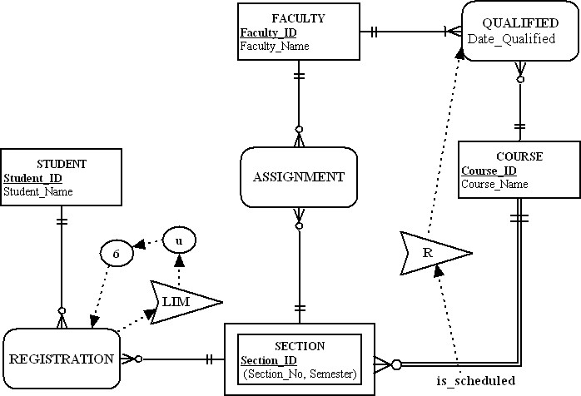

10.

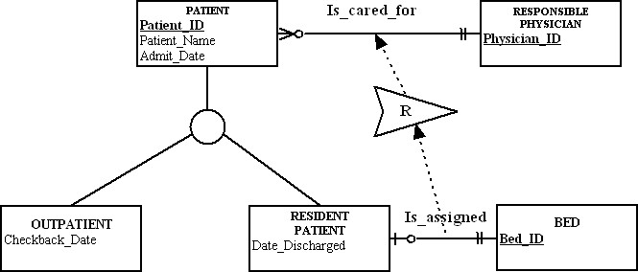

  - Anchor object: resident patient
  - Corresponding object: responsible physician

- Business rule: “A student may attend a concert only if that student has completed his/ her homework”:
a. and b.
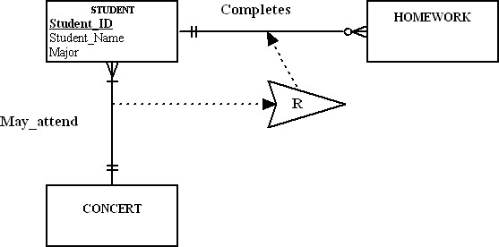

c. Anchor object: student
Corresponding object: Has_completed (homework)

12. a. Sample definitions:
PATIENT: a person who has been admitted to the hospital, or to a treatment program administered by the hospital.
OUTPATIENT: a person who has been admitted to a program of treatment administered by the hospital.
RESIDENT PATIENT: a person who has been admitted for a stay in the hospital and assigned to a bed location.
RESPONSIBLE PHYSICIAN: a physician who has formally admitted to patient to the hospital.
BED: a hospital bed located within a room in the hospital.
Is_cared_for: the relationship between a physician and a patient admitted to the hospital by that physician.
Is_Assigned: the relationship between a resident patient and the hospital bed to which that patient is assigned.
Patient_ID: a patient’s social security number.
Patient_Name: a patient’s first and last name.
Admit_Date: the date when a patient was most recently admitted to the hospital or to a treatment program.
Checkback_Date: the date when an outpatient is scheduled for a return visit.
Date_Discharged: the date when a resident patient was discharged following the most recent stay in the hospital.
Physician_ID: a unique identification number for an admitting physician.
Bed_ID: a unique identification number for each hospital bed.
b. Sample integrity constraint action assertion:
Patient_ID
Each patient must have a unique patient ID.

Patient_Name
Each patient must have a first and last name.
Admit_Date
Each patient must have an admit date which is a date no greater than today.

Checkback_Date
Each outpatient must have a checkback date which is greater than or equal to
today’s date and can be null.

The checkback_date cannot be before the admit_date.

Date_Discharged
Each resident patient must have a discharge date.
The date discharged cannot be before the admit_date.

Physician_ID
Each responsible physician must have a unique physician id.

Bed_ID
Each bed must have a unique bed ID.

13.
  - Because only regular customers (as opposed to national customers) do business in a sales territory, then not all instances of the customer entity cluster do business in a selling unit. However, because all sales territories do business with at least one regular customer, then all sales territories do business with at least one instance of a customer entity cluster.

  - The attributes of item would be the attributes of PRODUCT and PRODUCT LINE from Figure 3-22: Product_ID, Product_Description, Product_Finish, Standard_Price, Product_line_ID, Product_Line_Name.

  - The attributes of material would be the attributes of RAW MATERIAL, Supplies, SUPPLIER, and VENDOR from Figure 3-22: Vendor_ID, Vendor_Name, Vendor_Address, Contract_Number, Supply_Unit_Price, Material_ID, Unit_of_Measure, Material_Name, Standard_Cost.

14. E-R Diagram from Chapter 3 Problem 7 with Entity Clusters:

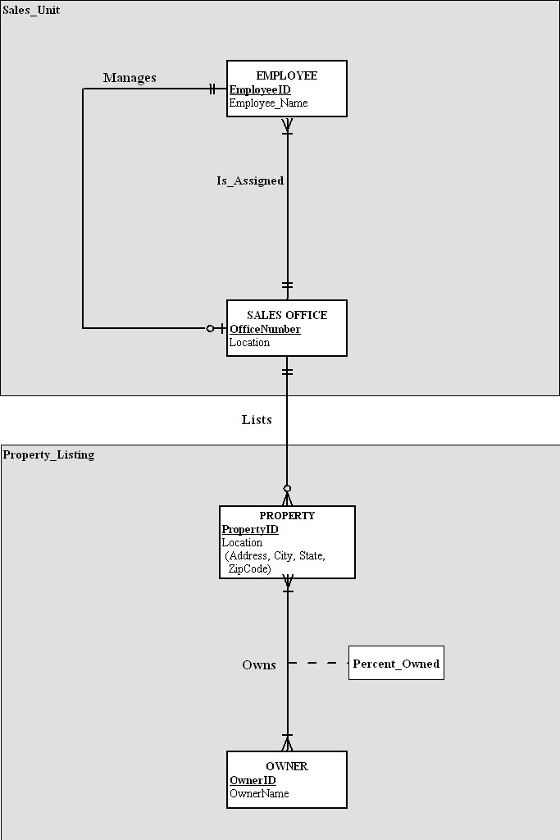
14 (continued)

The Sales_Unit cluster can be used by people only interested in how the business is managed, without concern for the properties listed.
The Property_Listing cluster can be used by people who are interested in property that is currently listed or who owns that property.

15. E-R Diagram from Chapter 3, Problem 12 with Entity Clusters:

There are three entity clusters: Project_Detail, Employee_Detail, and Dept_Detail.
Project_Detail contains the set of entities that would be used by one interested in the project without concern for the specific employees on the project. An assumption is that the only concern from the project side is to track employee skills and location, not individual employees.

The Employee_Detail cluster would be of most value to the user who was interested in what skills specific employees have as well as location. Other details are available in this cluster, such as marriage. This cluster was chosen since one can then isolate employee information without looking at project information.

The Dept_Detail cluster was chosen since one might not be concerned about vendors, however one might want to know what department a given employee works for. In the same way, one might want specifics about vendors without needing information about employees or projects.

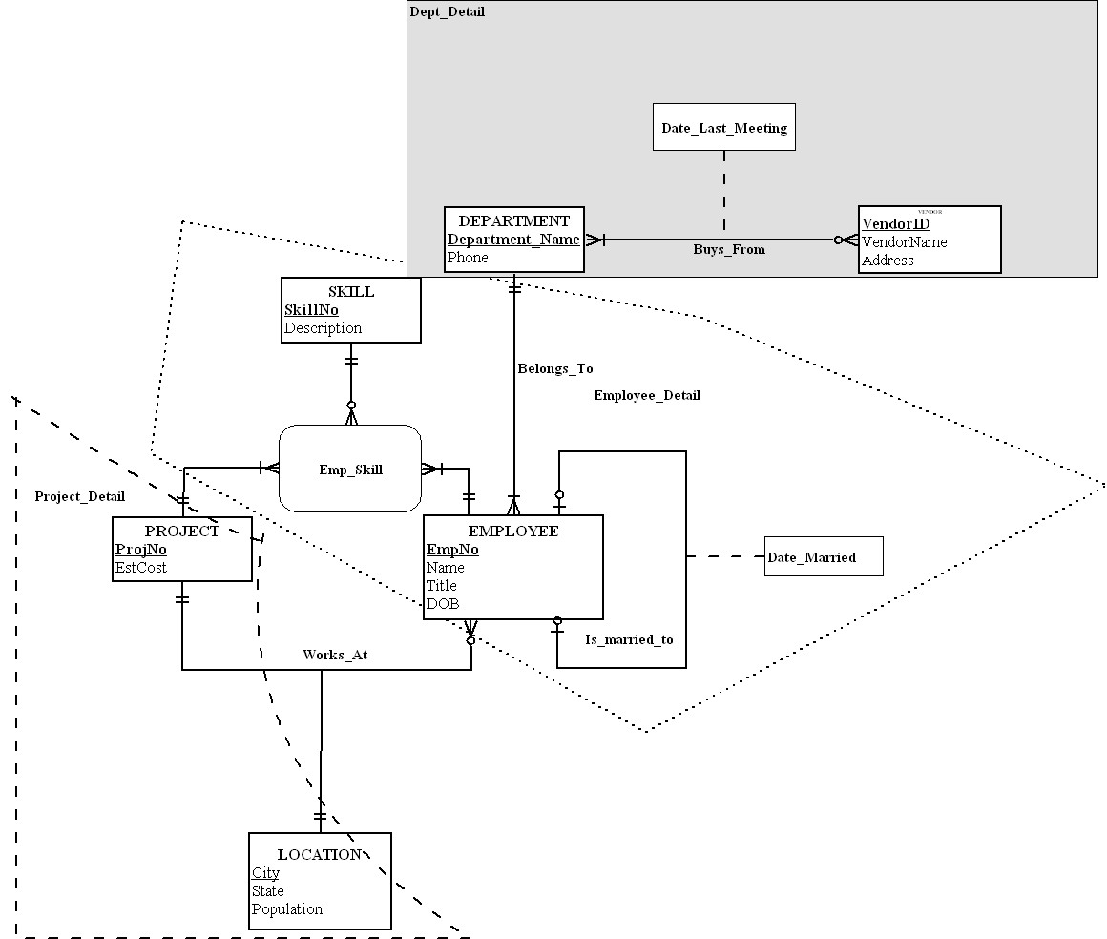

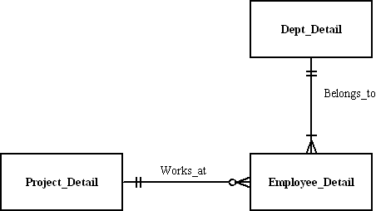
16. Notes to instructor: Student answers may vary depending upon their interpretation of the exercise situation. The solutions presented here are representative of possible answers, given certain assumptions. These notes are presented here for your reference:

a) An alternative solution could be to set ORGANIZATION as a supertype with INTERNAL and EXTERNAL subtypes. However, the exercise does not indicate unique attributes or special relationships between the proposed subtypes and any other entities, thus no supertype-subtype hierarchy is shown in these solutions. More questions would need to be asked of the end users to determine the appropriate model for this situation.

b) Another possible solution to this exercise would be to create a supertype of PARTY with subtypes of PERSON and ORGANIZATION. There is significant overlap of attributes between these two entity types that could suggest such a solution.

EER Notation:

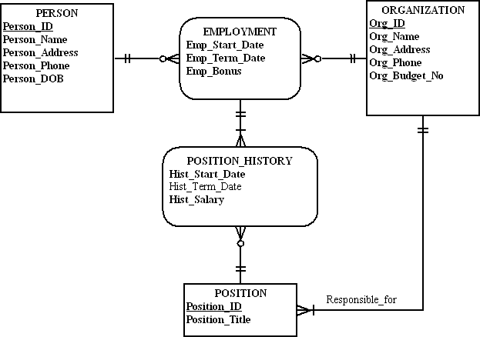
16) Visio Notation:
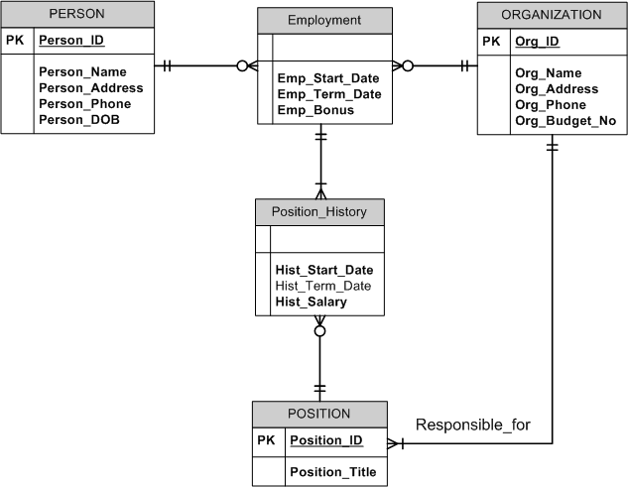

16) Subtypes within Supertypes Notation:
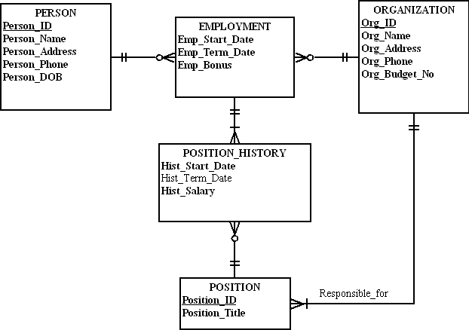

17. [Note to instructor: This Problem & Exercise has a different written scenario than a similar one in Chapter 3. The plural “requested judgment characteristics” in Chapter 3 is semantically different than this exercise’s “requested judgment characteristic” which results in the alternate model solution shown below. This may be useful to point out to students regarding the importance of paying attention to fine details while modeling data.]

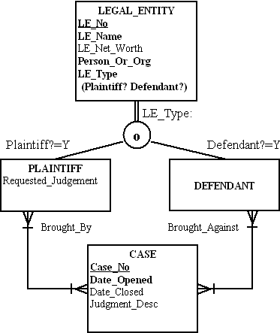

Notes:
1) Person_or_Org attribute denotes Person or Organization type of Legal Entity. There is no reason to show Person and Organization as subtypes of Legal Entity, as there are no special attributes or relationships identified.
2) The same legal entity cannot be both a Plaintiff and Defendant in the same Case.
3) Although DEFENDANT has no other unique attributes, it is required as a subtype to show the parties involved in a CASE. Further, the DEFENDANT subtype is necessary to show the Brought_Against role that is necessary to defining the parties in a CASE.
18. EER Notation

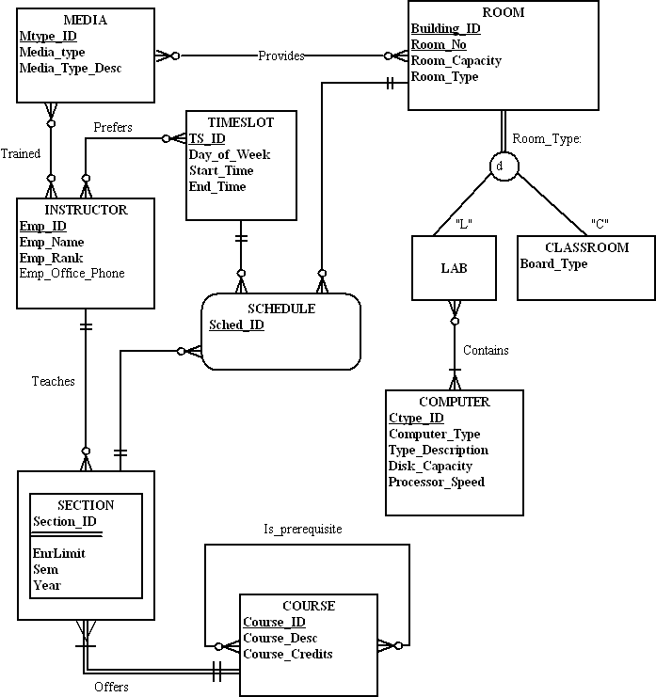
18) Visio Notation:

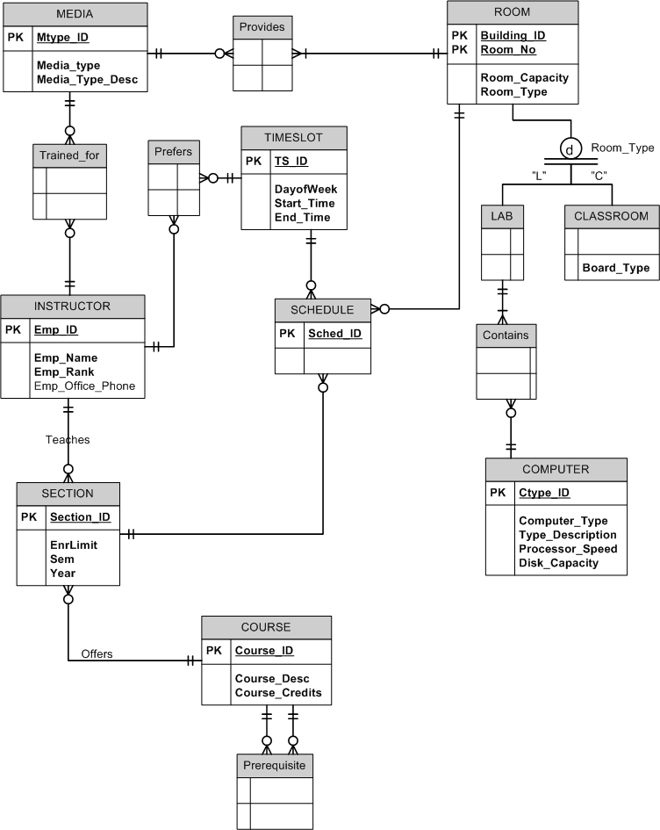
18) Subtype within Supertype Notation:
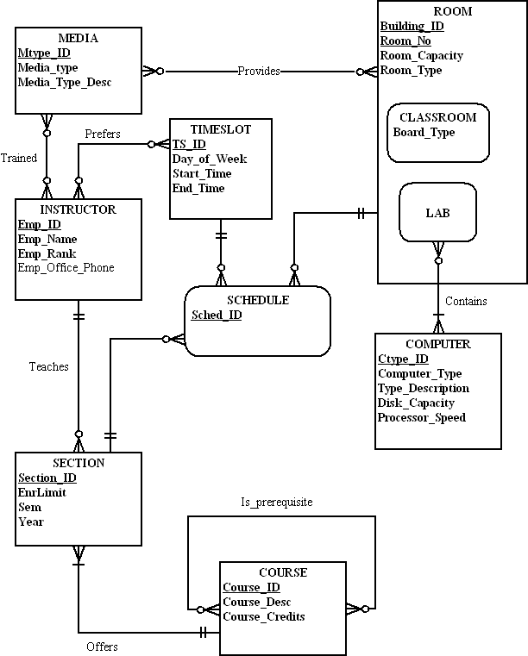

19. EER Notes (for all notations):
1) A CONSULTANT is either a Business or Technical consultant, not both.

EER Notation:

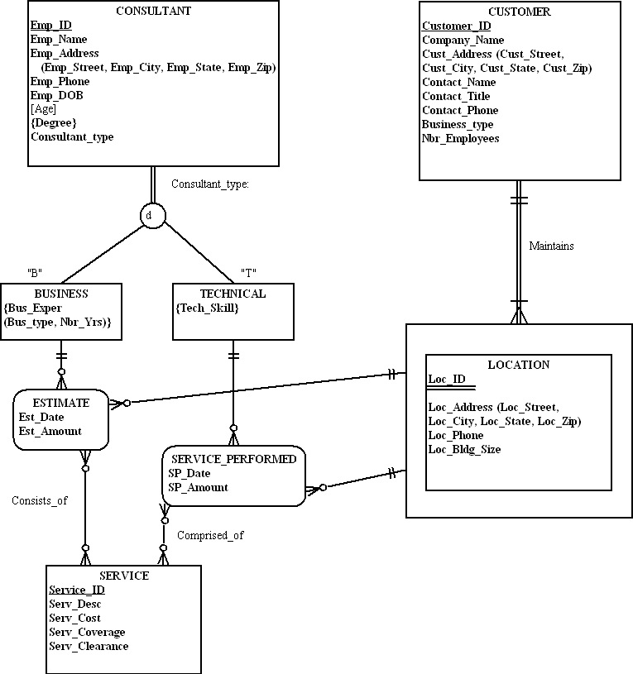
19) Visio notation:

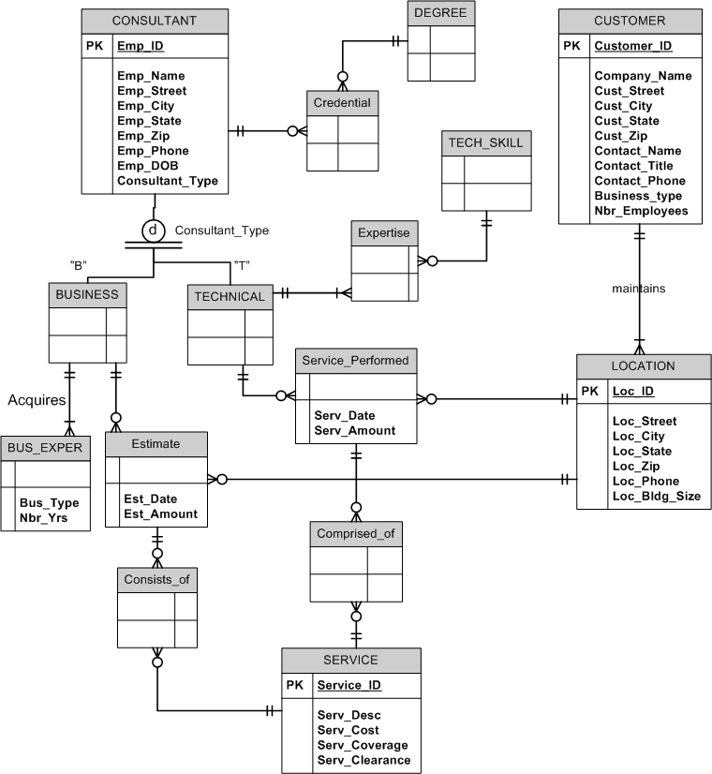
19) Subtype within Supertype Notation:

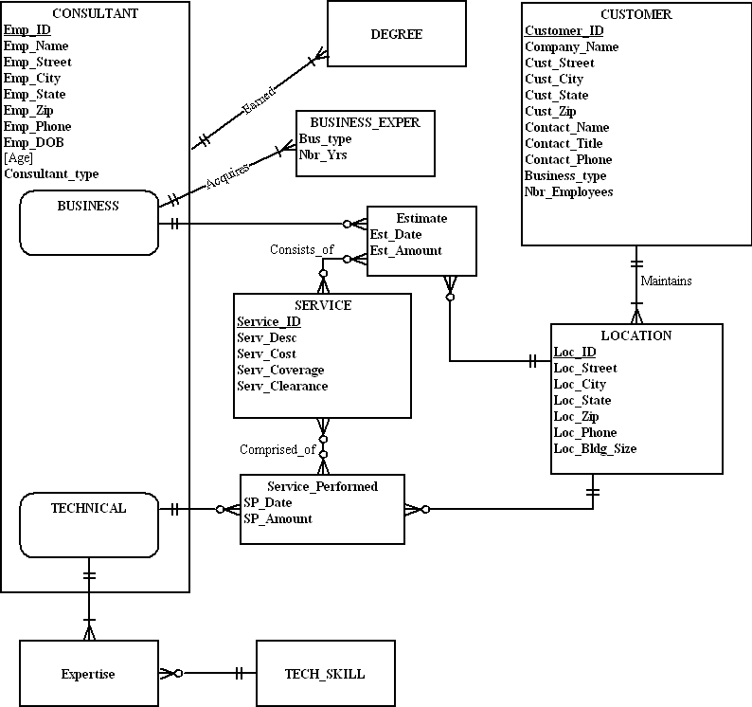

20.
a. Sample Definitions
CONSULTANT: a person who has signed an employment agreement or contract with the company, and who is on the company payroll.
BUSINESS CONSULTANT: a consultant who provides an estimate to a
customer.
TECHNICAL CONSULTANT: a consultant who provides security services to a
customer.
CUSTOMER: a business that requires security services.
LOCATION: one or more places of business for a customer.
SERVICE: a security service that can be performed.
Estimates: a written estimate prepared by a business consultant for a location.
Services_Performed: actual services performed by a technical consultant at one
location.
Emp_ID: a consultant’s employee id.
Degree: a consultant’s academic training.
Business Experience: a business consultant’s business experience.
Tech Skills: a technical consultant’s experience.
Coverage: how much of an area a service covers for a given location.

b. Sample integrity-constraint action assertions:
Emp_ID:
each consultant must have a unique employee id.
Employee_Name:
each consultant must have a name.
Address:
each consultant must have an address.
Degree:
consultants can have one, none or many degrees.
Business Experience:
business consultants can have one, none or many types of business
experience. For each type of experience, we also record the years.
Amount:
both services_performed and estimates can have a dollar value associated
with the service or estimate.

21.
a.
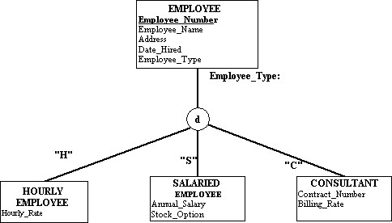

b.
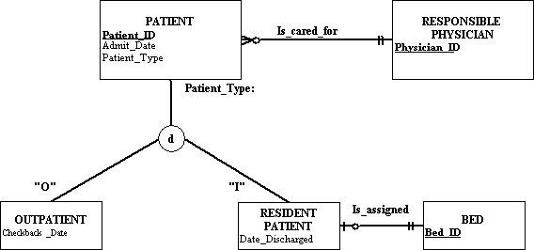

c.
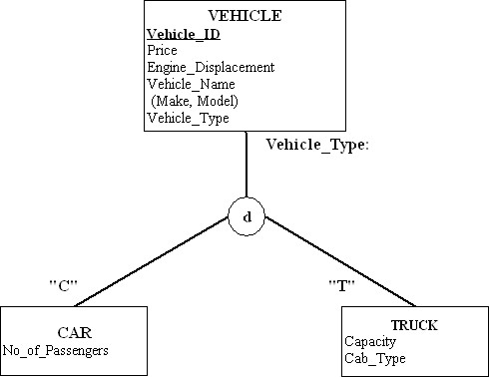

d.
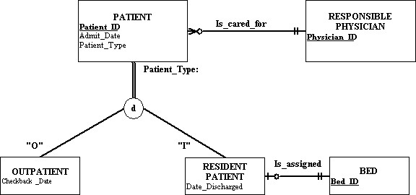

e.
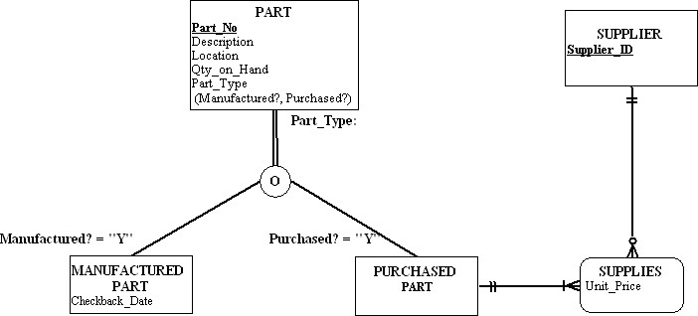

22.

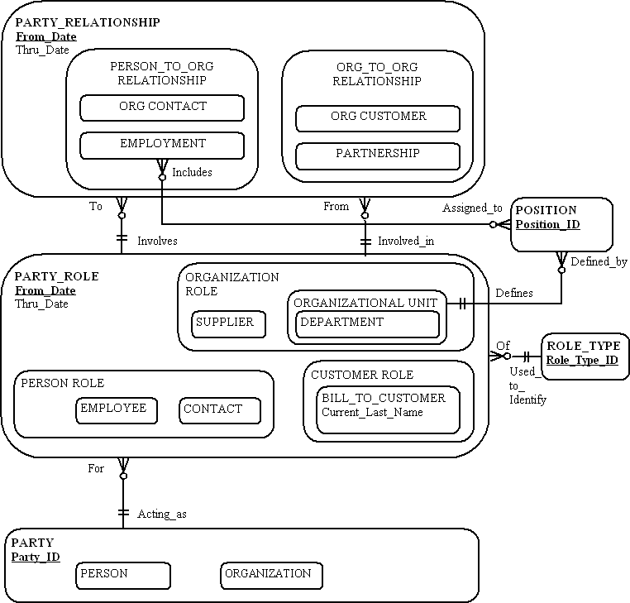

Notes:
1) A PERSON, in his/her EMPLOYMENT, may hold multiple POSITIONs or not yet have an assigned POSITION (this is shown with the 0:M cardinality near POSITION from EMPLOYMENT).
2) A POSITION might initially be unfilled, or over time, may be filled with multiple EMPLOYMENT instances of PERSONs (this is shown with the 0:M cardinality near EMPLOYMENT from POSITION).

23.

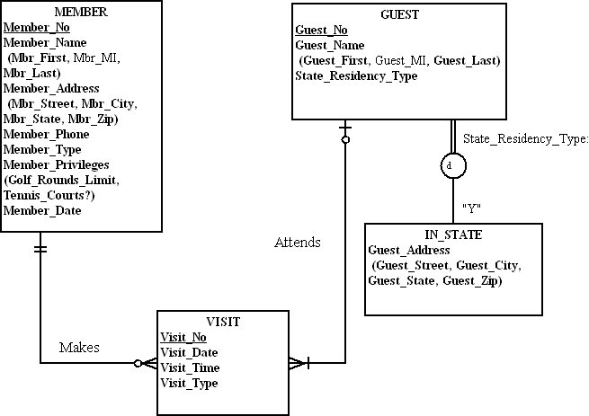

Notes for EERD:
1) Member_Type values are Golf or Non-Golf.
2) Social and Tennis members are considered Non-Golf members. A Social member has a Golf_Rounds_Limit of 2 and Tennis_Courts? = N. A Tennis member has a Golf_Rounds_Limit of 4 and Tennis_Courts?=Y. A Golf member has a Golf_Rounds_Limit of 999 and Tennis_Courts?=Y.
3) Golf members’ visits are tracked only if they bring a guest.
4) If a Guest becomes a Member, then Guest records are archived out of the database.
5) Member_Date tracks the membership date of the Member.

24.
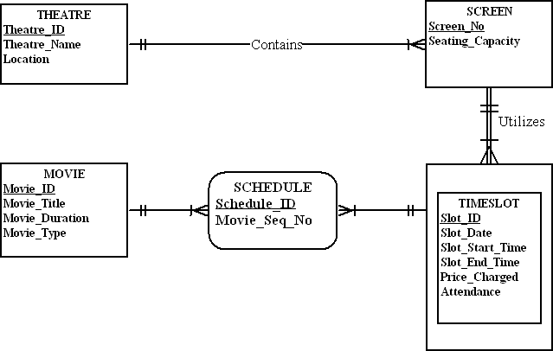

Notes for EERD:
1) Owners wish to know the attendance and price_charged for each TIMESLOT (i.e., there is a charge with an attendance to see everything shown on a SCREEN in the same TIMESLOT).
2) Movie_Seq_No tracks the sequence in which movies are shown in the TIMESLOT (e.g., in a timeslot there might be two trailers, followed by two commercials, followed by a feature film, and closed with a commercial).

Suggestions for Field Exercises

- Common examples of EER constructs:
- Supertype/subtype relationships. Ask your students to try to try to find an example of each of the rules described in the chapter: disjoint, overlapping, partial specialization, and total specialization. Also, for each example, have your students identify a candidate subtype discriminator. Ask your students to justify the use of supertype/subtype relationships for each of these examples, using the guidelines stated in the chapter.
- Business rules. For each example, ask your students to first state the rule using structured English (following the format described in the chapter), then draw an E-R diagram segment with the rule superimposed on the diagram.

- We suggest that you use this exercise as a continuation of Field Exercise 2 in Chapter 3. Ask your students to determine whether supertype/subtype relationships are formally modeled in the corporate E-R diagrams. Also, ask your students to determine how business rules are stated and enforced by each organization.

- We suggest you assign this exercise in conjunction with Field Exercise 4 in Chapter 3.

- Following are several questions that can be used to structure this report:
- How are business rules defined?
- Why are business rules important to an organization?
- What are alternative methods for capturing and expressing business rules?
- What advantages can an organization realize by formally capturing business rules?

- One good place for students to begin would be to perform a google search on business rules engine software. This will bring them to several sites, such as www.tcs.com

- One good Web site for students to go to in their research is www.universaldatamodels.com

Project Case

Case Questions

1. Yes, the ability to model supertype/subtype relationships is likely to be very important for a hospital. A modern hospital is a triumph of specialization. Many hospital entities are likely to have subtypes, for example:
ITEM: possible subtypes are Supply, Item, and Prescription Item
PATIENT: possible subtypes are Inpatient and Outpatient
TEST: possible subtypes are Scan and Blood test
PROCEDURE: possible subtypes are Biopsy and Surgical

2. Yes, the business rules paradigm can be used for competitive advantage. Business rules allow a business to change its processes and procedures quickly in responding to environmental changes. Hospitals are under intense cost pressures and new government regulations. Process improvements and regulations, if implemented through clear business rules, will make it easier to react to changes.

3. Yes, the entity VISIT (scheduled for outpatients) is clearly a weak entity.

4. A hospital has many business rules. Two examples are the following:
- A patient cannot be admitted to the hospital without a referral from a responsible physician.
- A nurse can be reassigned to a different care center only by permission of the nurse in charge of the care center where the nurse is presently assigned.

5. A universal data model for Mountain View Community Hospital would work out well, since hospital applications are quite common. Of course, there would still need to be customization. One justification would be to look at the cost versus the cost savings from developing a database application completely from scratch.

Case Exercises
1. [Note to instructor: When assigning this exercise to students, be sure to allow a sufficient amount of time for completion. The case scenario is fairly complex and will encourage students to do a lot of thinking and experimenting prior to developing a workable diagram. Due to the large size of the diagram, and the necessary notes to the diagram, this solution is presented in three parts: notes, diagram (without attributes displayed), and a “diagram” of the entities with all attributes displayed.]

Business Rules/Notes for EERD (diagram on next page):
1. Only one entry for the Patient’s Emergency Contact Information is stored in the database.
2. Only the primary insurance information for the Patient is stored in the database. Secondary insurance information (if provided by the Patient) will be stored in paper files.
3. Referring/Primary Care Physician Contact information is stored as part of the PHYSICIAN entity in the database.
4. MVCH wants to track the history of all volunteer assignments within the facility, thus there is a need to use an associative entity (VOL_SERV_HISTORY) to track over time the various volunteer assignments, and each assignment’s supervisor, as well as the total amount of hours worked on each assignment. Some WORK_UNITs do not have VOLUNTEERs, thus a 0:M cardinality is required on its relationship with the associative entity.
5. A VOLUNTEER may be supervised by an EMPLOYEE or a PHYSICIAN at one time. Only one of these “supervision” relationships is active at one point in time, although both are shown on the diagram.
6. MVCH wants to track VOLUNTEER information at the point of application, thus it is possible that a VOLUNTEER instance may not yet have a corresponding instance of VOL_SERV_HISTORY in the database system (this is why there is a 0:M cardinality nearest the VOL_SERV_HISTORY associative entity on the relationship from VOLUNTEER).
7. A Registered Nurse (RN) may direct one, none, or several Licensed Practical Nurses (LPNs); a single LPN will be directed by only one RN. MVCH wishes to track these RN direction responsibilities for accountability and quality control purposes within the hospital.
8. A Floater nurse is not assigned to a CARE_CENTER, thus this is why there is a 0:M cardinality shown near CARE_CENTER on the Assigned relationship. If discussion with end users indicate additional attributes or relationships that are associated with Floater nurses, then an alternative solution could be to establish a FLOATER subtype entity on the diagram. The addition of this FLOATER subtype could allow the cardinality of the Assigned relationship for the NURSE supertype to be changed to 1:M.
9. Skill is modeled as a multivalued attribute of TECHNICIAN as it only relates to this entity and has no additional characteristics mentioned in the case. Under different assumptions, an alternative solution could be to model Skill as its own entity type with a relationship to TECHNICIAN (and possibly other entity types in the model).
10. Only current STAFF and TECHNICIAN assignments to WORK_CENTERs are necessary for this case.
11. Only current BED to RESIDENT associations are necessary in the database.

CE1: EERD (Note: attributes by entity are shown on next page; attributes omitted here to conserve space)
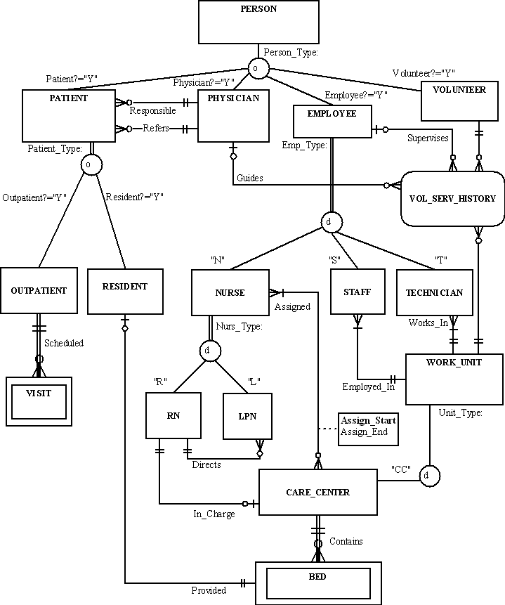

CE1: Attributes listed by entity
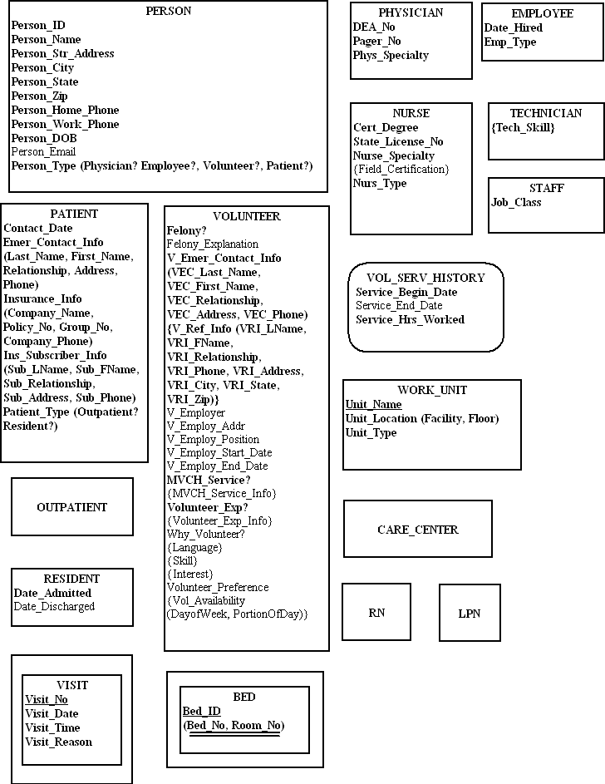

2. A clear approach is to establish two relationships between RN and CARE_CENTER: Day_in_charge, Night_in_charge. See proposed revision to diagram below.

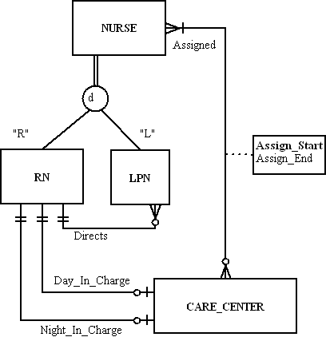

3. Following are some sample definitions:
a. Entity types:
Physician- a person who is licensed to practice medicine in this state.
Patient- a person who has been admitted to Mountain View Community Hospital or who is currently being treated as an outpatient by the hospital.
Employee- a person who has an employment agreement with the hospital and who is on the hospital payroll.
Care center- an organizational unit that performs a related set of services directed toward patient care.

b. Attributes:
Person_ID- a unique identifier for each person that does not violate privacy guidelines such as those outlined in HIPAA (e.g., not social security number).
Birth_Date- month, day, and year a person was born.
Specialty- a physician’s or nurse’s area of practice.
Location- the floor number and hospital wing for a work unit in the hospital (e.g., care center or diagnostic unit).

c. Relationships:
Provided- associates a resident patient with a hospital bed.
Scheduled- associates an outpatient with an instance of a visit to the hospital.

4.
PARTY: Person and Organization/Facility
PARTYROLE: There are PersonRoles: Patient, Physician, Employee, Volunteer. Within Employee there are additional roles: Nurse, Staff and Technician. Within Patient, there are additional roles: Resident and Outpatient.
PARTYRELATIONSHIP: There are Person-to-Person relationships: Patient to Physician There are also Person to Organization: Nurse to Care_Center; Staff, Technician to Work_Unit.
EVENTS: Communication events include in-person, e-mail and correspondence. Transactions events include orders and tests.
PRIORITY_TYPE: If a patient is acute, then his status will be resident.
STATUSTYPE: When a patient is discharged.
EVENTROLE: Patient, Nurse, Physician.
ROLETYPE: Person or Organization.

5.
A VOLUNTEER may have one EMERGENCY CONTACT. An EMERGENCY CONTACT may be for more than one VOLUNTEER.

A VOLUNTEER must have exactly two REFERENCES. A REFERENCE can act as a
reference for more than one VOLUNTEER.

A VOLUNTEER must have exactly one last EMPLOYER. An EMPLOYER can employ more than one VOLUNTEER.

A VOLUNTEER may have previous volunteer experience.

A VOLUNTEER may have one or more Skills. A VOLUNTEER also may have no Skills.

A VOLUNTEER may have one or more Hobbies. A VOLUNTEER also may have no Hobbies.

A VOLUNTEER may have one or more Interests. A VOLUNTEER also may have no Interests.

A VOLUNTEER may speak one or more Languages (in addition to English).

A VOLUNTEER may have one or more TIMESLOT preferences. A TIMESLOT may be chosen by one or more VOLUNTEERS.

6. The rule can be restated as follows:
“For a nurse to be appointed nurse-in-charge of a care center, that nurse must possess an RN certificate.”

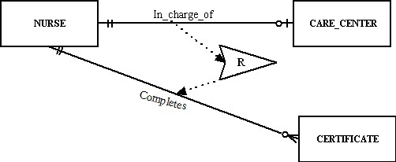

- Anchor object: nurse (entity)
- Corresponding object: RN Certificate (entity).

- You can perform a side-by-side comparison to show how the EER diagram provides a more detailed and complete statement of requirements for the hospital. For example, the EER diagram includes information about technicians as well as volunteers.

PROJECT ASSIGNMENTS

P1. A PERSON can be a PATIENT, PHYSICIAN, EMPLOYEE or VOLUNTEER. An instance of PERSON may be more than one of these.

A PATIENT may be only a RESIDENT PATIENT or an OUTPATIENT and cannot be both.

AN OUTPATIENT is scheduled for one or more VISITs. An OUTPATIENT can also be scheduled for no VISITs. A VISIT is for only one OUTPATIENT.

AN EMPLOYEE may only be a NURSE, STAFF or TECHNICIAN and cannot be more than one of these.

A NURSE may be only a Registered Nurse (RN) or Licensed Practical Nurse (LPN) and cannot be both. An RN will direct the work of one, none, or many LPNs: LPN’s work will be directed by only one RN.

A TECHNICIAN is assigned to one or more DIAGNOSTIC_UNITs. A DIAGNOSTIC_UNIT has one or more TECHNICIANS.

A FACILITY can contain one or more WORK_UNITs or may contain no WORK_UNITs. A WORK_UNIT is part of one and only one FACILiTY. Currently defined WORK_UNITs include CARE_CENTERs and DIAGNOSTIC_UNITs.

A CARE_CENTER has at least one, and usually many NURSEs assigned to it. Each CARE_CENTER has one RN assigned as a nurse_in_charge for the day shift, and one RN assigned as a nurse_in_charge for the night shift. Some NURSEs are floaters and are not assigned to a particular CARE_CENTER and will work for more than one CARE_CENTER over time; non-floater NURSEs are assigned to a particular CARE_CENTER.

A CARE_CENTER may contain one or more beds or may contain not BEDS, A BED is contained in only one CARE_CENTER.

A DIAGNOSTIC_UNIT performs one or more TREATMENTs. A TREATMENT is performed by only one DIAGNOSTIC UNIT.

A BED is assigned to one RESIDENT PATIENT or no RESIDENT PATIENTs. A RESIDENT PATIENT is assigned to one BED.

A PHYSICIAN admits one or more PATIENTs or admits no PATIENTs. A PATIENT is admitted by only one PHYSICIAN.

A PHYSICIAN may refer one or more PATIENTs or may refer no PATIENTs. A PATIENT must be referred by one PHYSICIAN.

A PATIENT may consume many ITEMS or may consume no ITEMS. An ITEM is consumed by one or more PATIENTS or may be consumed by no PATIENTS.

An ITEM is supplied by one or more VENDORs. A VENDOR may supply one or more items or may supply no ITEMs.

A PHYSICIAN may write one or more ORDERs or may write no ORDERs for one PATIENT. An ORDER is written by one PHYSICIAN.

An ORDER may consist of one or more ITEMs or no ITEMs. An ITEM may be part of one or more ORDERS or may be part of no ORDERS.

An ORDER may consist of one or more TREATMENTS or no TREATMENTs. A TREATMENT may be part of one or more ORDERs, or no ORDERs.

A PHYSICIAN may complete one or more DIAGNOSES for one or more PATIENTs. A DIAGNOSIS is Completed for one PATIENT by one PHYSICIAN.

P2. [Note to instructor: When assigning this exercise to students, be sure to allow a sufficient amount of time for completion. The case scenario is fairly complex and will encourage students to do a lot of thinking and experimenting prior to developing a workable diagram. Due to the large size of the diagram, and the necessary notes to the diagram, this solution is presented in three parts: notes, diagram (without attributes displayed), and a “diagram” of the entities with all attributes displayed.]

Business Rules/Notes for EERD (diagram on next page):
1. Only one entry for the Patient’s Emergency Contact Information is stored in the database.
2. Only the primary insurance information for the Patient is stored in the database. Secondary insurance information (if provided by the Patient) will be stored in paper files.
3. Referring/Primary Care Physician Contact information is stored as part of the PHYSICIAN entity in the database.
4. MVCH wants to track the history of all volunteer assignments within the facility, thus there is a need to use an associative entity (VOL_SERV_HISTORY) to track over time the various volunteer assignments, and each assignment’s supervisor, as well as the total amount of hours worked on each assignment. Some WORK_UNITs do not have VOLUNTEERs, thus a 0:M cardinality is required on its relationship with the associative entity.
5. A VOLUNTEER may be supervised by an EMPLOYEE or a PHYSICIAN at one time. Only one of these “supervision” relationships is active at one point in time, although both are shown on the diagram.
6. MVCH wants to track VOLUNTEER information at the point of application, thus it is possible that a VOLUNTEER instance may not yet have a corresponding instance of VOL_SERV_HISTORY in the database system (this is why there is a 0:M cardinality nearest the VOL_SERV_HISTORY associative entity on the relationship from VOLUNTEER).
7. A Registered Nurse (RN) may direct one, none, or several Licensed Practical Nurses (LPNs); a single LPN will be directed by only one RN. MVCH wishes to track these RN direction responsibilities for accountability and quality control purposes within the hospital.
8. A Floater nurse is not assigned to a CARE_CENTER, thus this is why there is a 0:M cardinality shown near CARE_CENTER on the Assigned relationship. If discussion with end users indicate additional attributes or relationships that are associated with Floater nurses, then an alternative solution could be to establish a FLOATER subtype entity on the diagram. The addition of this FLOATER subtype could allow the cardinality of the Assigned relationship for the NURSE supertype to be changed to 1:M.
9. Skill is modeled as a multivalued attribute of TECHNICIAN as it only relates to this entity and has no additional characteristics mentioned in the case. Under different assumptions, an alternative solution could be to model Skill as its own entity type with a relationship to TECHNICIAN (and possibly other entity types in the model).
10. Only current STAFF and TECHNICIAN assignments to WORK_CENTERs are necessary for this case.
11. Only current BED to RESIDENT associations are necessary in the database.
12. A NURSE prepares one, none, or many ASSESSMENTs of PATIENTs; A PATIENT receives one to many ASSESSMENTs over time.
13. Assessment_ID is unique (surrogate) identifier for ASSESSMENT.
14. A DIAGNOSTIC_UNIT is defined to include Labs and other hospital WORK_UNITs that perform procedures, tests, and treatments required by ORDERs. A DIAGNOSTIC_UNIT performs one to many TREATMENTs; A TREATMENT is performed by one DIAGNOSTIC_UNIT.
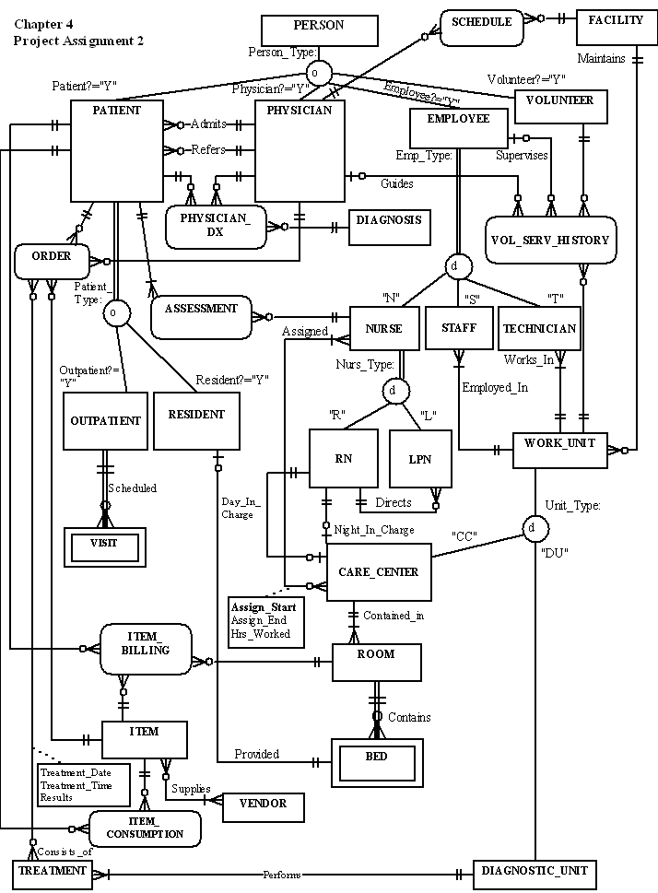
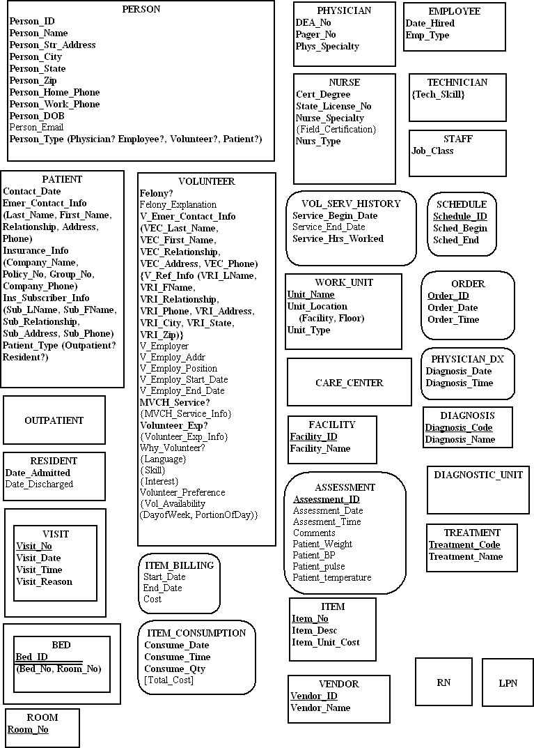
P3. [Note to instructors: Student answers may vary slightly; these issues are presented as a possible representation of issues which may be identified. An in-class comparison/contrast of selected student answers to this assignment and that from the prior chapter would be a good hands-on exercise for exploring the upcoming chapter 5 topic of merging issues (homonyms, synonyms, transitive dependencies, and supertype/subtype relationships). Comparing/contrasting the diagrams could lead to a useful discussion of the importance of understanding the meaning of the data in order to resolve issues and ensure appropriate capture of the end user’s data requirements.]

Some issues that come up during the merging:
- Should there be a relationship between DIAGNOSTIC_UNIT and TECHNICIAN?
- Are items consumed by both resident patients as well as outpatients? (diagram shows current assumption is ‘Yes’)
- What needs to be done to the data model to allow for follow up care for discharged patients.
- We kept the Admits relationship between PATIENT and PHYSICAN in place of the Responsible used in the original EER model (Case Exercise 1, Chapter 4); is this a correct understanding of the relationship, or is another relationship required to show the Responsible association?
- We assumed that the NURSE subtype (both RN and LPN) participates in the ASSESSMENT of PATIENTs and reflects the same relationship as shown by the EMPLOYEE relationship to ASSESSMENT in Chapter 3. Do other EMPLOYEE subtypes (e.g., STAFF or TECHNICIAN) prepare such ASSESSMENTs? Do both types of NURSEs prepare ASSESSMENTs?
- We assumed that a DIAGNOSTIC_UNIT is defined to include Labs and other hospital WORK_UNITs that perform procedures, tests, and treatments required by ORDERs. Is this a correct assumption or are there other WORK_UNITs that need to be tracked in the database?
- In chapter 3, a business rule was indicated that EMPLOYEEs are Assigned to CARE_CENTERs and that Hours_Worked needed to be tracked for each such assignment in the database. We interpreted this to mean the NURSE subtype in the chapter 4 EER diagram and have added the Hours_Worked attribute to the M:N Assigned relationship in the diagram.
- In chapter 3, the identifier for the BED weak entity was described as a composite identifier including Bed_No, Care_Center_ID, and Room_No. In chapter 4, the identifier for the BED weak entity was described as a composite identifier including Bed_No and Room_No. The correct identifier needs to be validated with the end users and finalized in the EER diagram listing of entities.

